

* Connect 4 with AI

Mohamed Zain Fayed

Mohamed Mahmoud Hashim

Mahmoud Magdy Faiek

Salem Magdy

# Environment

Connect Four is a 2 player game, which has 6 rows and 7 columns to put the tiles in it by choosing a certain column from 7,

* Each player has to make Four tiles arranged horizontally or vertically or at a diagonal to win the game before the other player to complete his four tiles
* So each player has to maximize his score by making more arranged tiles and the other one minimize the other’s score by blocking his tiles and building his arranged ones
* The environment is static during making a decision from one of the two players and the other player can change it too
* The implementation was in Android OS and C++ for desktop

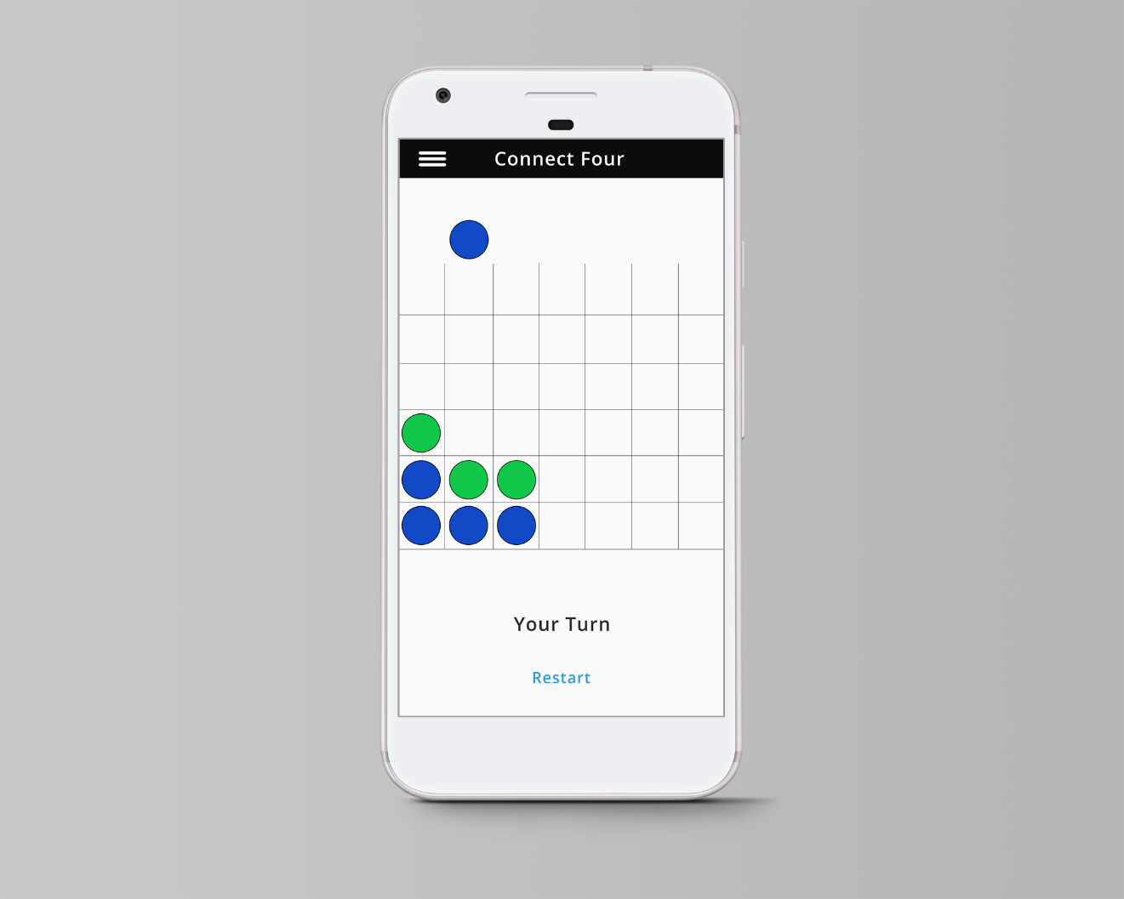

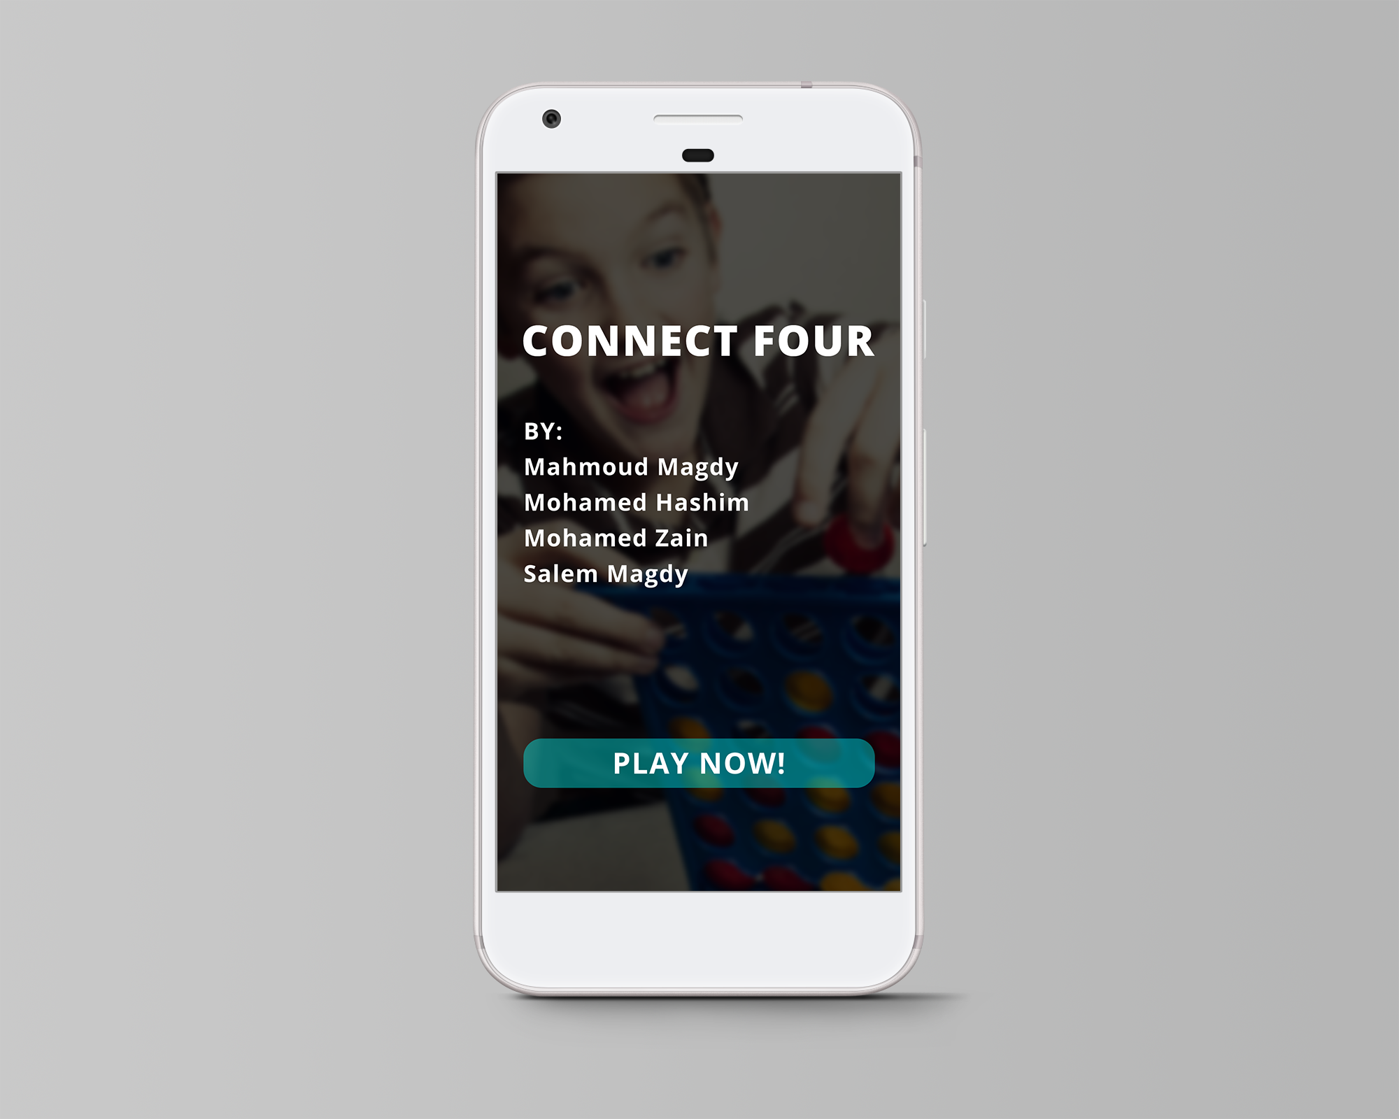

Used techniques

* MinMax Algorithm (Negamax variant)
* Bitmap representation to make all the computations using bitwise operations
* Alpha-Beta pruning
* Iterative deepening combined with Binary Search
* Traversing reordering using cost computations
* Transportation table (Simple hashing technique)